Ward Parkway Presbyterian Church
7406 Ward Parkway
Kansas City, MO 64114
Office use only
Approval Date______________
Deposit Received Date________
Deposit Returned Date________
Fees Due___________________
Fees Paid Date______________
Setup Complete Date_________
816-361-2200
www.wppresbyterian.org
office@wppresbyterian.org

FACILITY USAGE REQUEST FORM

Today’s Date:
Event Name:
Purpose:
Sponsoring Organization:
Organization: □ Member-Sponsored □ Non-Member-Sponsored
Date of Event: __________________ Day of week: __________ Time: ___________ to ____________
Number of People expected at event:
Contact Name:
Phone: _____________________________ Email: _________________________________________

Rooms requested:
□ Parlor □ Parlor Kitchenette □ Fellowship Hall □ Fellowship Hall Kitchen
□ Sanctuary □ Choir Room □ Holy Grounds □ Nursery
□ Library □ Steeple Tower (2nd Floor) Other_______________________________________
Rooms with food:
□ Parlor □ Parlor Kitchenette □ Fellowship Hall □ Fellowship Hall Kitchen
□ Sanctuary □ Choir Room □ Holy Grounds □ Nursery
□ Library □ Steeple Tower (2nd Floor) Other_______________________________________
Equipment requested:
□ Projector screen □ Chairs___________
□ Round tables (seat 6-8)________ □ Rectangular tables___________ □ Card tables________
What equipment, if any, will you bring into the facility?
____________________________________________________________________________________
Do you require access in advance to do your own setup? If so, when? ___________________________
Requested Set-up Assistance by WPPC (Note 1) ____________________________________________
Requested Set-up Assistance by WPPC Complete Date and Time: ______________________________

Note 1: If not a WPPC activity, a fee will apply.

If using Fellowship Hall, please draw a diagram of how you would like tables and chairs arranged.

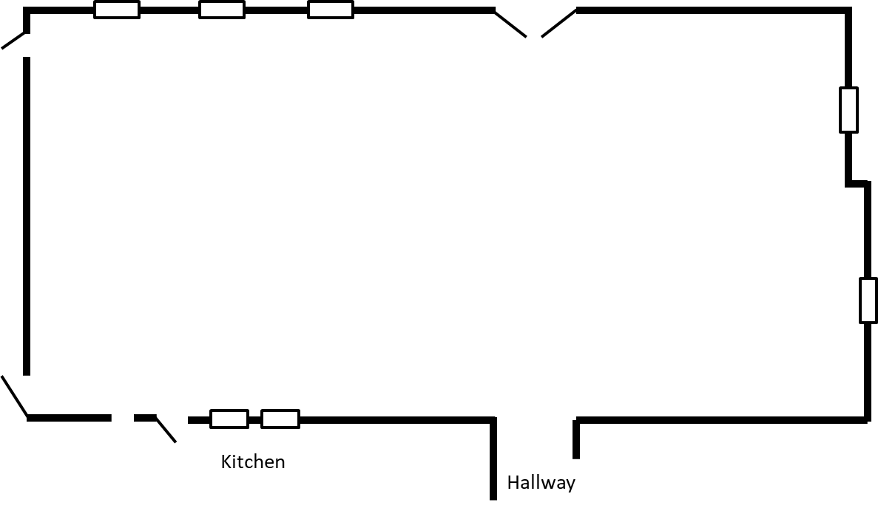
If using the Parlor, please draw a diagram of how you would like tables and chairs arranged.

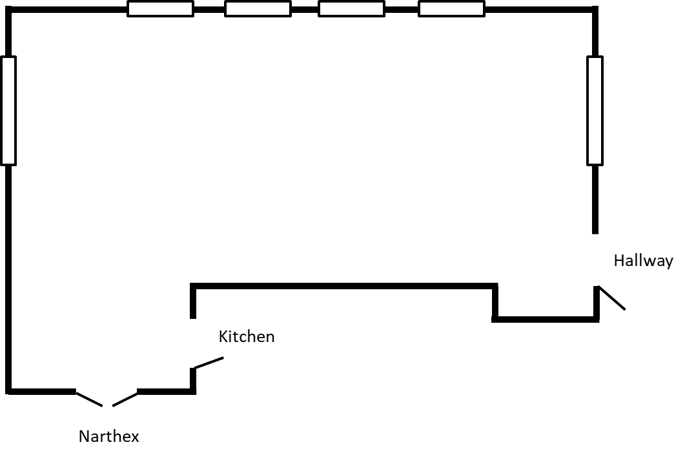
If using another room, do you need a special layout? _________________________________________

Signature of Contact Person:

Signature of Church Representative:

Ward Parkway Presbyterian Church
7406 Ward Parkway
Kansas City, MO 64114
816-361-2200
www.wppresbyterian.org
office@wppresbyterian.org

FACILITY USAGE AND HOLD HARMLESS AGREEMENT
I/We, the undersigned authorized representative(s) of
_________________________________of the city of ________________________________________,
state of____________________, shall be using the building and grounds of Ward Parkway Presbyterian
Church from____ _________________to_______________________, 20______, for the purpose of
___________________________________________________________________________________,
herein referred to as “the event.”

I/We understand and agree that neither Ward Parkway Presbyterian church nor its trustees, representatives, employees, or agents may be held liable in any way for an occurrence in connection with the activity that may result in injury, harm, or other damages to the undersigned or members of our organization and guests, invited or not.
As part of the consideration for being allowed to use your facility, building and grounds as well as all appliances and fixtures in the activity, I/we hereby assume all risk in connection with participation in the activity. I/We further release Ward Parkway Presbyterian Church, its trustees, employees, agents, or representatives for any damage that may occur while participating in the activity. I/We further agree to save and hold harmless Ward Parkway Presbyterian Church, its trustees, employees, agents, or representatives from any claim by the undersigned member of ,
its estates, heirs, or assigns arising out of or participation in any form or fashion in the activity. I/We also authorize Ward Parkway Presbyterian Church, its employees or agents to render or obtain such emergency medical are or treatment as may be necessary should any injury, harm, or accident occur while participating in the activity.
I/We further state that I/we are authorized to sign this agreement; that I/we understand the terms herein are contractual and not mere recital; and that I/we have signed this document of my/our own free act and volition. I/We further state and acknowledge that I/we have fully informed ourselves of the content of this affirmation and release by reading it before I/we signed it.

I/We have executed this affirmation and release on the ______ day of ______________, 20______

Signature:

Signature:

Ward Parkway Presbyterian Church
7406 Ward Parkway
Kansas City, MO 64114
816-361-2200
www.wppresbyterian.org
office@wppresbyterian.org

Overview
Ward Parkway Presbyterian Church’s mission is Seek ~ Question ~ Learn ~ Grow.
We welcome everyone as we would welcome Jesus Christ. Our goals are to:
- Use our facility in a God-honoring way.
- Treat visitors as honored guests.
Facility usage is granted according to the following priority:
- Event supporting an organization, activity, board, or ad hoc group of Ward Parkway Presbyterian Church. Simply talk to the church administrative assistant to ensure there is availability.
- Member-Sponsored Event. Please submit a request through the church office. The church member must be present at the event. (Facility Usage Request Form required)
- Non-Member-Sponsored Event. Any outside group/organization in harmony with the mission statement of the church. “Outside group” is defined as any organization that is not part of Ward Parkway Presbyterian Church, any other Presbyterian organization, or an organization that does not have a church member as a member of that group. (Facility Usage Request Form required)
Outside for profit private profit-making organizations or individuals shall not be granted building use.

Facility Usage Request Form (FURF)
A FURF is required for a Member-Sponsored or Non-Member-Sponsored event.
A FURF must be completed and submitted to the church office at least 15 days in advance of the event. The form is required for every area of the church. An exception to the time requirement may only be made in situations of emergency and with approval of the church office.
Upon receipt of the FURF and deposit, the church office is responsible to schedule review of the request. Approval by the Session may be required.
If a group is approved for recurring events, the same group with the same event may schedule continuously without requirement of additional FURFs. Cost must be negotiated.

Deposit and Payment
A $50 deposit will be accepted with application submission and returned if the application is denied.
The balance of the usage fee must be paid no later than one day prior to the event.

Insurance
Outside groups shall provide proof of insurance within 7 days of building use approval and at least 7 days prior to the scheduled use of facilities. The church may consider exempting one-time use groups from this requirement.
The church will not be responsible for any private property in the event of vandalism, loss, fire, or theft.

Damage to Church Property
Damage to church property shall be reported immediately to the office in person or by phoning 816-361-2200 (leave a message if no one answers.) DO NOT try to fix items yourself.
The area(s) used by the organization will be examined carefully after each use, and the organization assumes full liability for damage to or loss of property which may occur.
When the church determines, in consultation with the group, that the services of the church custodian are required, the group will be charged the normal hourly fee.
FAILURE TO ABIDE BY THESE AGREEMENTS WILL JEOPARDIZE FURTHER USE OF THE FACILITIES.

Usage Fees
Rates below are daily unless otherwise specified.

 | Member | Non-Member
Parlor | $35 | $70
Parlor Kitchenette | $25 | $40
Fellowship Hall (see Note 1) | $50 day  $30 half-day | $100 day  $60 half-day
Fellowship Hall Kitchen | $30 | $50
Sanctuary (see Note 2) | $50 | $150
Choir Room | $25 | $40
Holy Grounds | $25 | $40
Nursery | negotiable | negotiable
Library | $25 | $40
Steeple Tower (2nd floor) | $50 | $150
Grounds | $50 | $100
North parking lot | $30 | $60
South parking lot | $50 | $100

Notes:
1. Food storage does not require Kitchen rental.
2. Sanctuary use requires an additional agreement that neither the piano nor the organ is to be played without consent of both the Pastor and Organist.
3. The sound system is to be operated by WPPC AV team members. An additional fee will apply. Services may be quoted on an as-needed basis.
4. Weekly rates are available at a cost of 4 times the daily rate.

Facility Use Regulations
- The rules and restrictions in this section apply to all church property, both inside and outside
- In case of emergency, dial 911.
- For problems or urgent matters needing attention, call Steve (816-668-4907) or Pastor Nancy (303-564-8360)
- The church office phone number is not to be listed for inquiries about an event sponsored by an outside group.
- No weapons, smoking, illegal drugs, or gambling are permitted.
- Equipment and furnishings of the church shall not be removed from the church property unless approved by the Pastor or Operations Elder.
- Food & beverages
- No alcoholic beverages unless approved by Session.
- Where food and beverages are permitted, their use is restricted to the room(s) approved.
- If used, the Fellowship Hall Kitchen should be completely cleaned when finished.
- Special instructions that require movement of equipment and or furniture shall be submitted no later than five days prior to use
- All facilities must be vacated by 10:00 p.m. unless arranged otherwise in advance.
- Do not attach or fasten anything to walls or doors.
- Use only dry erase markers on white boards.
- Please lift rather than slide furniture if it must be moved.
- If Sanctuary is being used:
- No food or beverages in Sanctuary.
- No use of the church organ or piano except by permission of the Pastor and Organist.
- Piano is not to be moved except by permission of the Pastor and Organist.
- The audio & visual system is to be operated by WPPC AV team members only. An additional fee will apply.
- If the Choir Room is being used:
- No use of the piano except by permission of the Pastor and Organist.
- Piano is not to be moved except by permission of the Pastor and Organist.
- During the event
- Building security must be ensured throughout the event.
- Use of a church telephone is for brief local and emergency calls only.
- Sufficient supervision shall be provided by the organization sponsoring the event to ensure good order and protection of property, and prevention of persons wandering around the building.
- All children’s or youth activities shall be supervised by a minimum of two adults over the age of twenty-one (21).
- When children are in attendance, they must be under the control of parents or adults at all times and are not permitted to roam freely throughout the building or on the grounds.
- Use of the elevator at the South end of the education building is permitted in the general conduct of approved church activities.
- Clean-up and building security after the event
- Group using the facilities is expected to straighten up after themselves and leave space as they found it, or set up as specified.

Exceptions
A request for an exception to any of these requirements shall be made in writing to the church office

